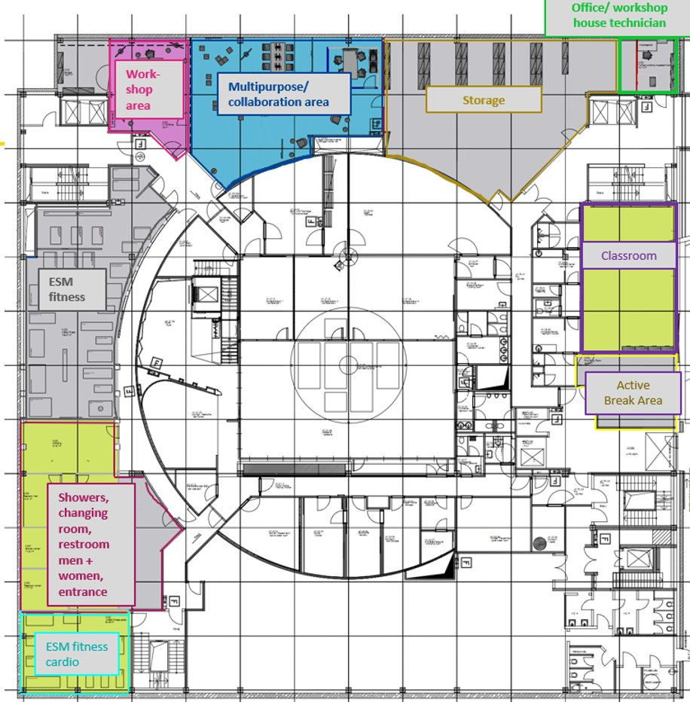
The -1 floor area is currently being rebuilt, a more detailed floor plan will be provided once the plans are available
ESM Floorplans for Soft Services
Floor -01
-01
ESM Floorplans for Soft Services
Floor 00
00
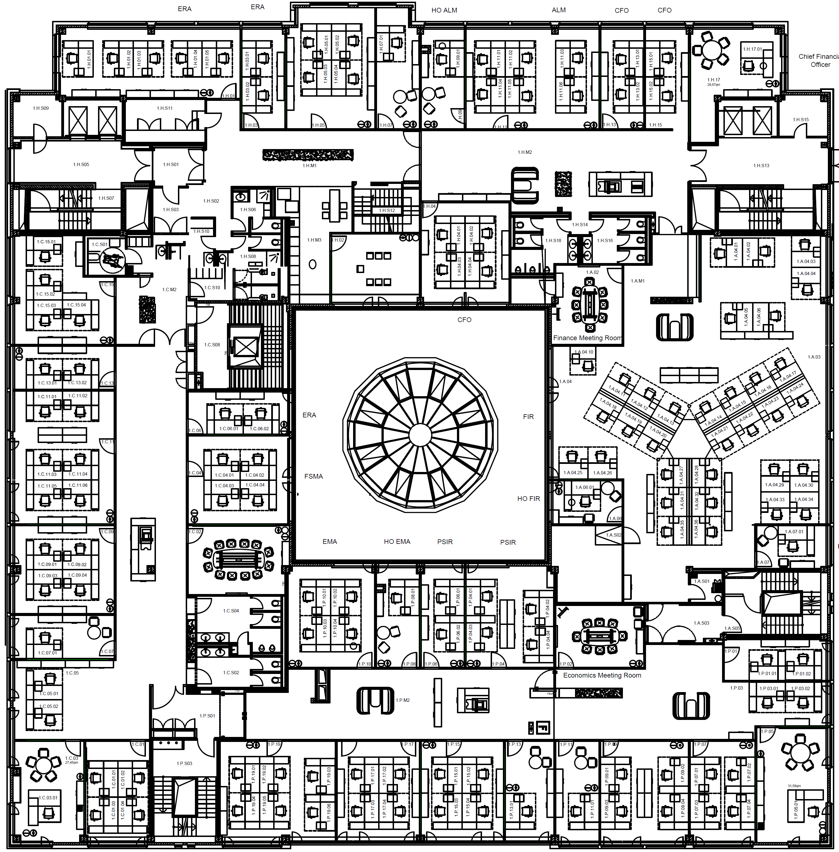
ESM Floorplans for Soft Services
Floor +01
+01
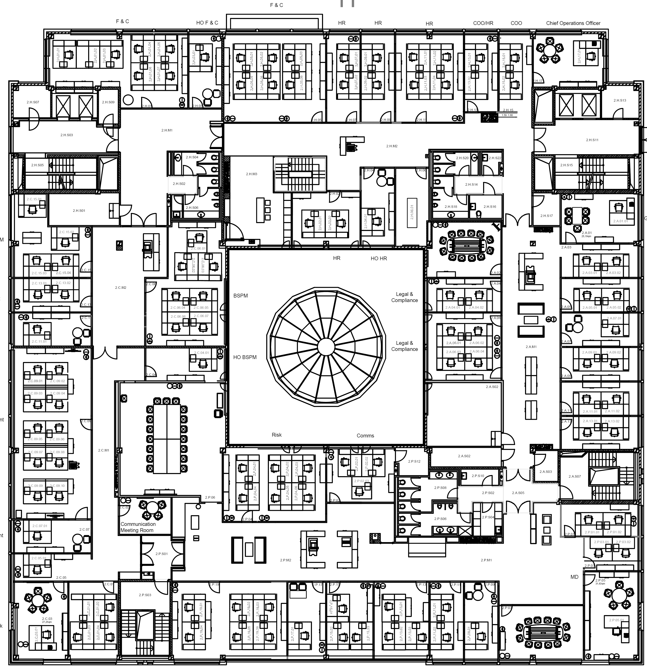
ESM Floorplans for Soft Services
Floor +02
+02

