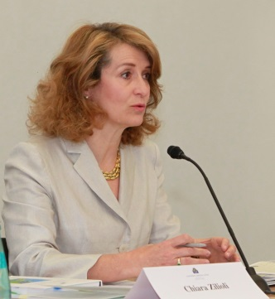
Chiara Zilioli
Professor Chiara Zilioli has dedicated her entire working life to the European integration project. In 1989 she joined the Legal Service of the Council of Ministers in Brussels, moving to the Legal Service of the European Monetary Institute in 1995 and subsequently to the ECB as Head of Division in Legal Services in 1998. She was appointed Director General of the ECB’s Legal Services in 2013.
She holds an LL.M. from Harvard Law School and a PhD from the European University Institute. She lectures at the Institute for Law and Finance at Goethe University Frankfurt, where she was appointed Professor of Law in 2016, and at the European College of Parma, Parma University. She has published numerous articles and three books. She is a member of the Parma Bar Association.
Professor Zilioli has been married to Dr Andreas Fabritius for more than 30 years; they have four wonderful children.

